

SRM university AP, Neerukonda – kuragallu village, Mangalagiri Mandal, Guntur Distict,   
Andhra Pradesh.  
  
School of Engineering and Sciences.

Participants in our Project:

AP23110011178. -Shaik Mohammad.  
AP23110011169. - K. Narendra Kumar. AP23110011186. – Shaik Abdullah AP23110011196. - Md.Nabeel Hisham  
AP23110011201. -P.Pavan Kumar

**C-LANGUAGE PROGRAMMING PROJECT**

Project Title: *C- BoxOffice - Movie and Event TICKET Booking System*

### **Introduction**

#### **1. Project Overview**

C BoxOffice is a comprehensive movie and event booking system that allows users to browse movies, book tickets for shows, and purchase tickets for upcoming events. The system provides details about now showing and coming soon movies, as well as this weekend and next weekend events.

#### **2. Objective**

The primary objective of the C BoxOffice system is to simplify the process of booking movie tickets and event tickets, providing users with a convenient and efficient way to plan their entertainment activities.

#### **3. System Architecture**

#### **Programming Language**

The system is implemented in C programming language, providing a command-line interface for users.

#### **Modules**

* The project is organized into several modules to manage different functionalities: **Main Module**,**Movie Module**,**Event Module**,**Booking Module**,**Transaction Module**,**Print Ticket Module**
* A Overview of this project we did using C-language:
* Beginning of this code we used four header files i.e,

#include <stdio.h>

#include <stdlib.h>

#include<string.h>

#include <time.h>

* Provided the Driver code in the main function

int main() {

printf("\n\t\t\tWELCOME TO C BOXOFFICE......\n\n");

int choice;

do{

printf("1.Movies\t\t2.Events\n"); ----- **Selection of choice**

printf("Enter your choice:");

scanf("%d", &choice);

switch (choice) {

case 1:

movie();

break;

case 2:

events();

break;

default:

printf("Invalid choice\n");

}

printf("Press any key to return menu...\n");

getchar(); // Consume the newline character

getchar(); // Wait for user input

}while(choice!='2');

return 0;}

* **In the above code the two functions movie(); and events(); are further defined with their respective tasks**

void movie() {

printf("1.Now Showing\t\t2.Coming Soon\n");

printf("Enter Category:");

int movieChoice;

scanf("%d", &movieChoice);

* **Using switch function here we implemented selection of choice b/w now showing and coming soon movies**

switch (movieChoice) {

case 1:

nowShowing();

break;

case 2:

comingSoon();

break;

default:

printf("Invalid choice\n");

}

}

* **Using library functions of time.h we get to update dates of movies**

char* getCurrentDate() {

time_t t;

time(&t);

struct tm* currentDate = localtime(&t);

char* formattedDate = (char*)malloc(20);

strftime(formattedDate, 20, "%Y-%m-%d", currentDate);

return formattedDate;

}

* **Function for movies currently showing**

void nowShowing() {

// ... existing code for movie details)

char* currentDate = getCurrentDate();

int dateComparison = strcmp(currentDate, releaseDates[c - 1]);

* **Allow booking if the current date is on or after the release date**

if (dateComparison >= 0) {

// ... ( existing code for ticket booking or movie review)

} else {

printf("Movie is not released yet.\n");

}

}

* **Function for coming soon movies**

void comingSoon() {

// ... (existing code for coming soon movies)

}

* **Function for events**

void events() {

// ... (your existing code for events)

}

* Now the required functions like access of location ,screen of theatre,Transaction , printing ticket are separately well defined …

**// Function for location selection**

void location() {

// ... (existing code for location selection)

}

**// Function for screen selection**

void screen() {

// ... ( existing code for screen selection)

}

**// Function for transaction**

void transaction() {

// ... (your existing code for transaction)

}

**// Function for printing the ticket**

void print_ticket() {

// ... (your existing code for printing the ticket)

}

* **After defining them we called those functions in main as the program runs and make use of for the ticket Booking system**

int main() {

movie(); // Call the movie function to start the program

events();

nowshowing();

comingsoon();

location(); //all functions called in main

screen(); as their needs for

transaction(); the real time program

print_ticket();

etc

return 0;}

## “SOURCE CODE”-this source code is of 635 lines

## #include <stdio.h>

## #include <stdlib.h>

## #include<string.h>

## #include<time.h>

## // Function declarations

## void movie();

## void events();

## void thisWeekend();

## void nextWeekend();

## void nowShowing();

## void comingSoon();

## void location();

## int screen();

## void transaction();

## void print_ticket();

## // Global variables

## char sno[15],str[10],sname[20],arr[5];

## char releaseDates[2][20] = {"2023-11-01", "2023-11-03"};

## int bookedSeats[5][10] = {0};

## int a,b,c,d,e,f,g,h,l,m,n,o,p,q,s,t,u,mon,year,w;

## int gy,i,j,k,r,loc,cvv=0,otp,x,z;

## int cost=0,adult=0,kid=0,couple=0,sp;

## // Driver Code

## int main() {

## printf("********************************************************************************\n");

## printf("\n\t\t\tWELCOME TO C BOXOFFICE......\n\n");

## printf("********************************************************************************\n");

## int choice;

## do{

## 

## printf("1.Movies\t\t2.Events\n");

## printf("Enter your choice:");

## 

## 

## scanf("%d", &choice);

## switch (choice) {

## case 1:

## movie();

## break;

## case 2:

## events();

## break;

## 

## default:

## printf("Invalid choice\n");

## }

## printf("Press any key to return menu...\n");

## getchar(); // Consume the newline character

## getchar(); // Wait for user input

## 

## }while(choice!='2');

## return 0;

## }

## void movie() {

## printf("1.Now Showing\t\t2.Coming Soon\n");

## printf("Enter Category:");

## int movieChoice;

## scanf("%d", &movieChoice);

## switch (movieChoice) {

## case 1:

## nowShowing();

## break;

## case 2:

## comingSoon();

## break;

## default:

## printf("Invalid choice\n");

## }

## }

## char* getCurrentDate() {

## 

## time_t t;

## time(&t);

## struct tm* currentDate = localtime(&t);

## char* formattedDate = (char*)malloc(20);

## strftime(formattedDate, 20, "%Y-%m-%d", currentDate);

## return formattedDate;

## }

## void nowShowing() {

## printf("\nThe movie list is..................\n");

## printf("1. DUNKI\t\t2. SAALAR\n");

## printf("Choose a movie: ");

## scanf("%d", &c);

## // Validate movie choice

## if (c < 1 || c > 2) {

## printf("Invalid choice\n");

## return;

## }

## // Display movie details, including release date

## printf("\nMovie: %s\n", (c == 1) ? "DUNKI" : "SAALAR");

## printf("Release Date: %s\n", releaseDates[c - 1]);

## // Check if the movie is released based on the current date

## char* currentDate = getCurrentDate();

## int dateComparison = strcmp(currentDate, releaseDates[c - 1]);

## // Allow booking if the current date is on or after the release date

## 

## 

## if(c==1) // Executes if DUNKI movie is chosen

## {

## printf("\n1.Book tickets\t\t2.Review\n");

## printf("Enter your option:");

## scanf("%d",&d);

## if(d==1) // Book Tickets

## {

## location();

## printf("\n1.Theatre A\t\t2.Theatre B\n");

## printf("Choose a theatre for DUNKI:\n");

## scanf("%d",&e);

## if(e==1) //Theatre Selection ::: Movie-->Book Tickets-->Theatre A

## {

## printf("Choose A's show timings for DUNKI...\n");

## printf("1.Morning\t\t2.Afternoon\n");

## printf("Choose an option:");

## scanf("%d",&f);

## if(f==1) //movie 1--> theatre A--> morning

## {

## printf("\nWELCOME TO DUNKI'S MORNING SHOW IN THEATRE A....\n");

## screen();

## transaction();

## printf("please wait we are printing your ticket");

## print_ticket();

## }

## else //Movie 1 -->Theatre A --> Afteroon

## {

## printf("\nWELCOME TO DUNKI'S AFTERNOON SHOW IN THEATRE A.....\n");

## screen();

## transaction();

## printf("please wait we are printing your ticket");

## print_ticket();

## }

## }

## else // Movie 1 --> Theatre B

## {

## printf("\nChoose B's show timings for DUNKI\n");

## printf("1.Morning\t\t2.Afternoon\n");

## printf("Choose an option:");

## scanf("%d",&f);

## if(f==1) //Movie 1 --> Theatre B--> Morning

## {

## printf("\nWELCOME TO DUNKI'S MORNING SHOW IN THEATRE B....\n");

## screen();

## transaction();

## printf("please wait we are printing your ticket");

## print_ticket();

## }

## else // Movie 1 --> Theatre B --> Afternoon

## {

## printf("\nWELCOME TO DUNKI'S AFTERNOON SHOW IN THEATRE B.....\n");

## screen();

## transaction();

## printf("please wait we are printing your ticket");

## print_ticket();

## }

## }

## }

## else // Review on Movie 1

## {

## printf("\n\tReview of DUNKI....\n");

## printf(" Shah Rukh Khan's movie 'Dunki' is said to be based on the 'donkey route' or 'donkey flight' that lakhs of Indians take to reach countries like the US, the UK or some other European country.");

## 

## 

## printf("Overall Rating:4.5");

## }

## }

## else // Movie 2 is chosen

## {

## printf("\n1.Book tickets\t2.Review\n");

## printf("Enter your option:");

## scanf("%d",&d);

## 

## location();

## if(d==1) // Movie 2 -->Book Tickets

## {

## printf("\nChoose theatre for SALAAR:");

## printf("\n1.A theatre\t\t2.B theatre");

## printf("\nEnter your option:");

## scanf("%d",&e);

## if(e==1) // Movie 2 --> Book Tickets --> Theatre A

## {

## printf("\nChoose A's show timings for SALAAR");

## printf("\n1.Morning\t\t2.Afternoon\n");

## printf("Choose an option:");

## scanf("%d",&f);

## if(f==1) // Morning Show in Theatre A

## {

## printf("\n\t\tWELCOME TO SALAAR'S MORNING SHOW IN THEATRE A....\n");

## screen();

## transaction();

## printf("please wait we are printing your ticket");

## print_ticket();

## }

## else

## {

## printf("\n\t\tWELCOME TO SALAAR'S AFTERNOON SHOW IN THEATRE B.....\n");

## screen();

## transaction();

## printf("please wait we are printing your ticket");

## print_ticket();

## }

## }

## else // Movie 2--> Book Tickets --> Theatre B

## {

## printf("\nChoose B's show timings for SALAAR\n");

## printf("1.Morning\t\t2.Afternoon\n");

## printf("Choose an option:");

## scanf("%d",&f);

## if(f==1)

## {

## printf("\n\t\tWELCOME TO SALAAR'S MORNING SHOW IN THEATRE A....\n");

## screen();

## transaction();

## printf("please wait we are printing your ticket");

## print_ticket();

## }

## else

## {

## printf("\n\t\tWELCOME TO SALAAR'S AFTERNOON SHOW IN THEATRE B.....\n");

## screen();

## transaction();

## printf("please wait we are printing your ticket");

## print_ticket();

## }

## 

## }

## }

## else // Review Of Movie 2

## {

## 

## printf("\t\t Review of SALAAR....\n");

## printf("A gang leader tries to keep a promise made to his dying friend and takes on the other criminal gangs its a complete action drama and thriller movie .");

## 

## printf("Overall Rating:4");

## }

## }

## }

## void comingSoon() {

## printf("Coming soon movies are....\n");

## printf("1.PUSHPA-2\t2. DEVARA\n");

## printf("Enter your choice:");

## int eventChoice;

## scanf("%d", &eventChoice);

## if (eventChoice == 1) {

## printf("\n\t\tMovie name: PUSHPA-2\n\t\tRelease Date:15 August 2024\n\n");

## printf("Booking opens on 10 August 2024\n");

## } else if (eventChoice == 2) {

## printf("\n\t\tMovie name: Devara\n\t\tRelease Date:5 April 2024\n\n");

## printf("Booking opens on 1 April 2024\n");

## } else {

## printf("Invalid choice\n");

## }

## }

## void thisweekend()

## {

## printf("\n\n1.Haailand resort\t\t2.Music live\n");

## printf("Enter ur choice:");

## scanf("%d",&m);

## if(m==1)

## {

## 

## printf("\n\t\tWELCOME TO HAAILAND RESORT......\n");

## printf("\n1.Book tickets\t\t2.Overview\n");

## printf("Enter ur choice:");

## scanf("%d",&n);

## if(n==1)

## {

## printf("\nDate:\nSaturday\n15 December\n\nTime:6.00pm\n\n\t\tProceed....");

## printf("\nSelect ur category...\n");

## printf("\nAdults\n500/-\nEach ticket grants entry to 1 person....\n");

## printf("\nKids\n300/-\nEach ticket grants entry to 1 person....\n");

## printf("\nEnter number of adults and kids:");

## scanf("%d%d",&adult,&kid);

## 

## 

## printf("\nYou have to pay:%d",(500*adult)+(300*kid));

## transaction();

## 

## printf("please wait we are printing your ticket");

## print_ticket();

## }

## else

## {

## printf("\nHaailand grandly welcomes you to the fantastic event.....");

## printf("\nDiscover an endless combination of thrilling rides,water park,");

## printf("fantastic entertainment,delightful restaurants");

## }

## }

## else

## {

## 

## printf("\n\t\tWELCOME TO LIVE MUSIC.......\n");

## printf("1.Book tickets\t\t2.Overview\n");

## printf("Enter ur choice:");

## scanf("%d",&o);

## if(o==1)

## {

## printf("\nDate:\nSaturday\n15 December\n\nTime:3.00pm\n\n\t\tProceed....");

## printf("\nSelect ur category...\n");

## printf("\nAdults\n600/-\nEach ticket grants entry to 1 person....\n");

## printf("\nKids\n500/-\nEach ticket grants entry to 1 person....\n");

## printf("\nEnter number of adults and kids:");

## scanf("%d%d",&adult,&kid);

## 

## printf("\nYou have to pay:%d",(600*adult)+(500*kid));

## transaction();

## printf("please wait we are printing your ticket\n");

## print_ticket();

## }

## else

## {

## printf("\nLive music welcomes you....\n");

## printf("\nImmerse yourself in the world of music....ROCKZZZZZ");

## }

## }

## }

## // Next Week Events

## 

## void nextweekend()

## {

## printf("\n\n1.Cuba event\t\t2.TEDx event\n");

## printf("\nEnter ur choice:");

## scanf("%d",&p);

## if(p==1)

## {

## 

## printf("\n\t\tWELCOME TO CUBA EVENT......\n");

## printf("\n1.Book tickets\t\t2.Overview\n");

## printf("\nEnter ur choice:");

## scanf("%d",&q);

## if(q==1)

## {

## printf("\nDate:\nSaturday , 15 December\n\nTime:10.00pm\n\n\t\tProceed....");

## printf("\nOnly Couples are allowed...\n");

## printf("Wanna come...!\nBring your partner...\nDon't have one...\nFind one...");

## printf("\nCouple: 2000/-\nEach ticket grants entry to a couple....\n");

## printf("\t Location: Trendset mall\n5th floor\nVijayawada\nAndhra Pradesh");

## printf("\nEnter number of couples:");

## scanf("%d",&couple);

## 

## printf("\nYou have to pay:%d",(couple*2000)/*+(team*4500)*/);

## transaction();

## }

## else

## {

## printf("\nCuba welcomes you to the fantastic event.....");

## printf("Spend time with your loved ones....");

## }

## }

## else

## {

## 

## printf("\n\t\tWELCOME TO TEDx EVENT.......\n");

## printf("1.Book tickets\t\t2.Overview\n");

## printf("\nEnter ur choice:");

## scanf("%d",&s);

## if(s==1)

## {

## printf("\nDate:\nSaturday\n22 December\nTime:\n9.00am\n\n\t\tProceed....");

## printf("\nSelect ur category...\n");

## printf("\nAdults\n4000/-\nEach ticket grants entry to 1 person....\n");

## printf("\tLocation:Vijayawada,Andhra Pradesh\n");

## printf("\nEnter number of adults:");

## scanf("%d",&adult);

## 

## printf("\n\nYou have to pay:%d",(adult*4000));

## transaction();

## }

## else

## {

## printf("\nTEDx EVENT WELCOMES YOU....\n");

## printf("Explore yourself....\nBuild your thinking...........");

## }

## }

## }

## void events()

## {

## printf("Events are...\n");

## printf("\n1.this weekend\t\t2.next weekend\n");

## printf("\n\nSelect ur option:");

## scanf("%d",&l);

## if(l==1)

## thisweekend();

## else

## nextweekend();

## }

## // This weekend Events Function

## int screen() {

## int r, g, h, u,x, cost = 0;

## int bookedSeats[5][10] = {0}; // 2D array to keep track of booked seats

## // Displaying seat arrangement

## for (int j = 0; j < 5; j++) {

## for (int i = 0; i < 10; i++) {

## // Display seat

## printf(" |__| ");

## }

## printf("\n");

## }

## // Display screen

## printf("\n\n\t\t\tScreen\n");

## // Display seat numbers

## for (int i = 1; i <= 10; i++) {

## printf("\t%d ", i);

## }

## // Display row numbers

## for (int i = 1; i <= 5; i++) {

## printf("\n%d\t", i);

## }

## // User input for seat booking

## do {

## printf("\nEnter row & column (e.g., 1 3): ");

## scanf("%d %d", &r, &g);

## // Validate the row and column values

## if (r >= 1 && r <= 5 && g >= 1 && g <= 10) {

## // Check if the seat is already booked

## if (bookedSeats[r - 1][g - 1] == 0) {

## printf("Seat booked at Row %d, Column %d\n", r, g);

## cost += (r <= 3) ? 100 : 200;

## bookedSeats[r - 1][g - 1] = 1; // Mark the seat as booked

## } else {

## printf("Seat at Row %d, Column %d is already booked. Please choose another seat.\n", r, g);

## }

## } else {

## printf("Invalid seat selection. Please try again.\n");

## }

## // Ask if the user wants to book another ticket

## printf("Do you want to book another ticket? (yes=1/no=2): ");

## scanf("%d", &h);

## } while (h == 1);

## 

## printf("The price of the ticket you selected is 100/-");

## // Snacks selection

## printf("\nSNACKS TIME:\n");

## printf("1. Coke Cost: 200\n");

## printf("2. Popcorn Cost: 300\n");

## printf("3. Combo Cost: 450\n");

## printf("4. No Snacks\n");

## printf("Enter your choice: ");

## scanf("%d", &u);

## // Calculate total cost based on snack choice

## switch (u) {

## case 1:

## cost += 200;

## break;

## case 2:

## cost += 300;

## break;

## case 3:

## cost += 450;

## break;

## case 4:

## // No snacks

## break;

## default:

## printf("Invalid option\n");

## break;

## }

## // Display the total amount to be paid

## printf("You should pay: Rs. %d\n", cost);

## printf("Enter your mobile number:\n");

## scanf("%d",&x);

## // Perform transaction (you can add this part as per your needs)

## // transaction();

## return cost; // Return the total cost

## }

## void db()

## {

## printf("\n\t\t\t.......... TRANSACTION........");

## printf("\nEnter name as it appears on your card :");

## scanf("%s",&sname);

## printf("\nEnter your card number:");

## scanf("%s",&sno);

## printf("\nEnter expiry date(month&year):\n");

## scanf("%d %d",&mon,&year);

## printf("\nEnter CVV:");

## scanf("%d",&cvv);

## printf("\nEnter your OTP number:");

## scanf("%d",&otp);

## printf("YOUR TRANSACTION HAS BEEN DONE SUCCESSFULLY......\n");

## printf("...............\n");

## printf("YOUR TICKET IS BOOKED\n");

## printf("Enjoy the show......\n");

## printf("Thank you... Visit again...\n");

## printf("ALERT!!!");

## printf("You have a show in half an hour\n");

## }

## // Choosing Location

## void location()

## {

## printf("\nAvailable locations nearby....");

## printf("\n1.BENZCIRCLE\n2.BANK COLONY\n3.MACHAVARAM\n4.KANURU\n");

## printf("Enter your location:");

## scanf("%d",&loc);

## printf("\nThe available theatres are ....\n");

## if(loc==1)

## {

## printf("\nTheatre A is 3km from your location....");

## printf("\nTheatre B is 7km from your location....");

## }

## else if(loc==2)

## {

## printf("\nTheatre A is 8km from your location....");

## printf("\nTheatre B is 2km from your location....");

## }

## else if(loc==3)

## {

## printf("\nTheatre A is 1km from your location....");

## printf("\nTheatre B is 5km from your location....");

## }

## else if(loc==4)

## {

## printf("\nTheatre A is 6km from your location....");

## printf("\nTheatre B is 12km from your location....");

## }

## else

## printf("\nInvalid location.....");

## }

## // Transaction Function

## void transaction()

## {

## printf("\n\n\n1.Debit card\t2.Credit card");

## printf("\nEnter your mode of transaction:");

## scanf("%d",&w);

## if(w==1)

## {

## printf("\t\tDEBIT CARD TRANSACTION");

## db();

## }

## else if(w==2)

## {

## printf("\t\tCREDIT CARD TRANSACTION");

## db();

## }

## else{

## printf("Invalid choice");

## }

## 

## }

## void print_ticket() {

## printf("\n\n\t\t\t********** TICKET **********\n");

## printf("\t\t\tWELCOME TO C BOXOFFICE\n");

## printf("\t\t\t--------------------------\n");

## // Print movie or event details

## if (d == 1) {

## printf("\t\t\t\t MOVIE TICKET\n");

## printf("\t\t\t--------------------------\n");

## printf("\t\t\tMovie: %s\n", (c == 1) ? "DUNKI" : "SAALAR");

## printf("\t\t\tShow Date: %s\n", getCurrentDate());

## printf("\t\t\tShow Time: %s\n", (f == 1) ? "Morning" : "Afternoon");

## } else if (l == 1) {

## printf("\t\t\t\t EVENT TICKET\n");

## printf("\t\t\t--------------------------\n");

## printf("\t\t\tEvent: %s\n", (m == 1) ? "Haailand Resort" : "Live Music");

## printf("\t\t\tEvent Date: Saturday, 15 December\n");

## printf("\t\t\tEvent Time: %s\n", (m == 1) ? "6.00pm" : "3.00pm");

## } else if (l == 2) {

## printf("\t\t\t\t EVENT TICKET\n");

## printf("\t\t\t--------------------------\n");

## printf("\t\t\tEvent: %s\n", (p == 1) ? "Cuba Event" : "TEDx Event");

## printf("\t\t\tEvent Date: %s\n", (p == 1) ? "Saturday, 15 December" : "Saturday, 22 December");

## printf("\t\t\tEvent Time: %s\n", (p == 1) ? "10.00pm" : "9.00am");

## }

## printf("\t\t\t--------------------------\n");

## printf("\t\t\tLocation: %s\n", (loc == 1) ? "BENZCIRCLE" : (loc == 2) ? "BANK COLONY" : (loc == 3) ? "MACHAVARAM" : "KANURU");

## printf("\t\t\tTheatre: %s\n", (e == 1) ? "A" : "B");

## 

## printf("\n");

## printf("\t\t\t--------------------------\n");

## 

## printf("\t\t\t--------------------------\n");

## printf("\t\t\tEnjoy the show!\n");

## printf("\t\t\t--------------------------\n");

## printf("\t\t\tThank you for choosing C BOXOFFICE\n");

## printf("\t\t\t********** TICKET **********\n");

## }

## After Compilation….

***Compiled Successfully.***

**OUTPUT**

* 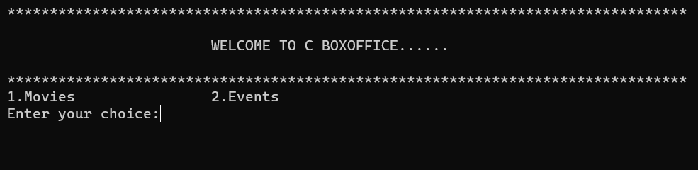After compiling and running This is the first output it came and allows us to select the choice of movie or events to book tickets
* 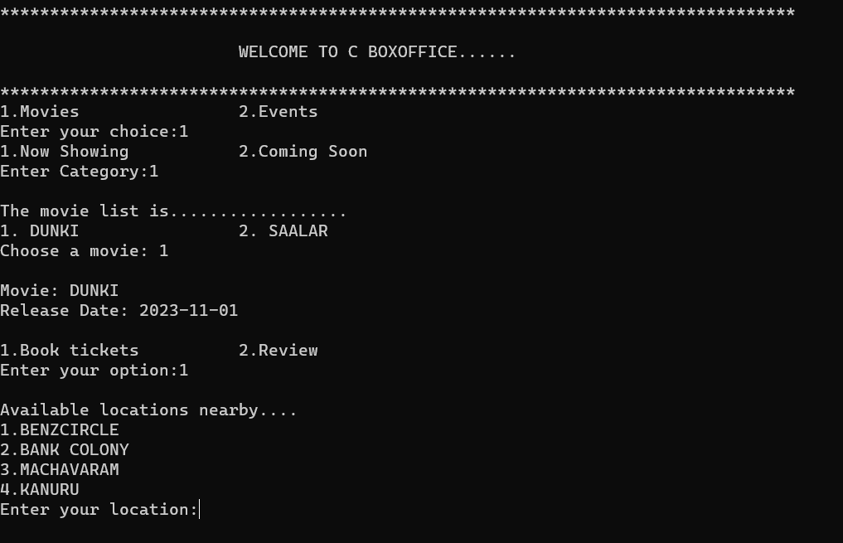After selecting choice (here we selected movies you can also choose events )Asks to select movies available and after selecting also outputs the release date and asks to choose b/w book tickets and reviewing the movie you can select any one …after choosing book tickets now gives the list of locations to choose.
* 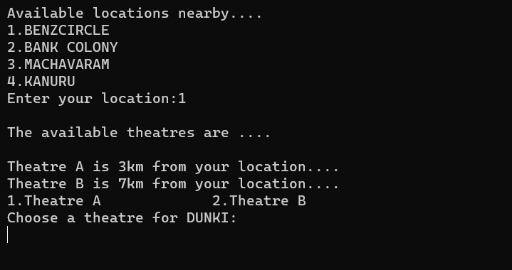Now after choosing the location you want then it gives list the theatres available near to you and allows you to choose the theatre
* After choosing your location it ask you the showtime here I simply provided morning and afternoon after choosing it gives access to the screen and allows to select ticket by entering row and column you want

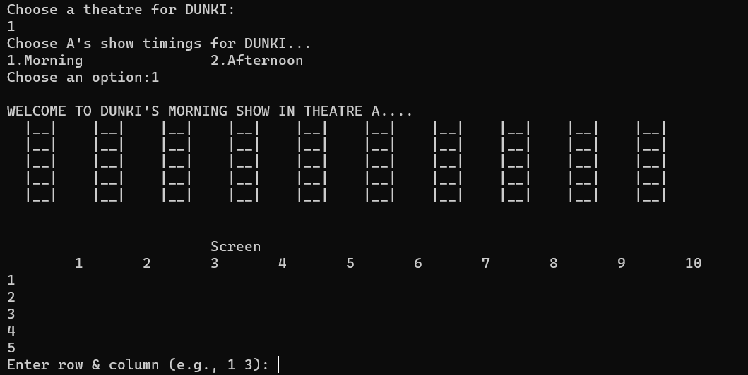

* 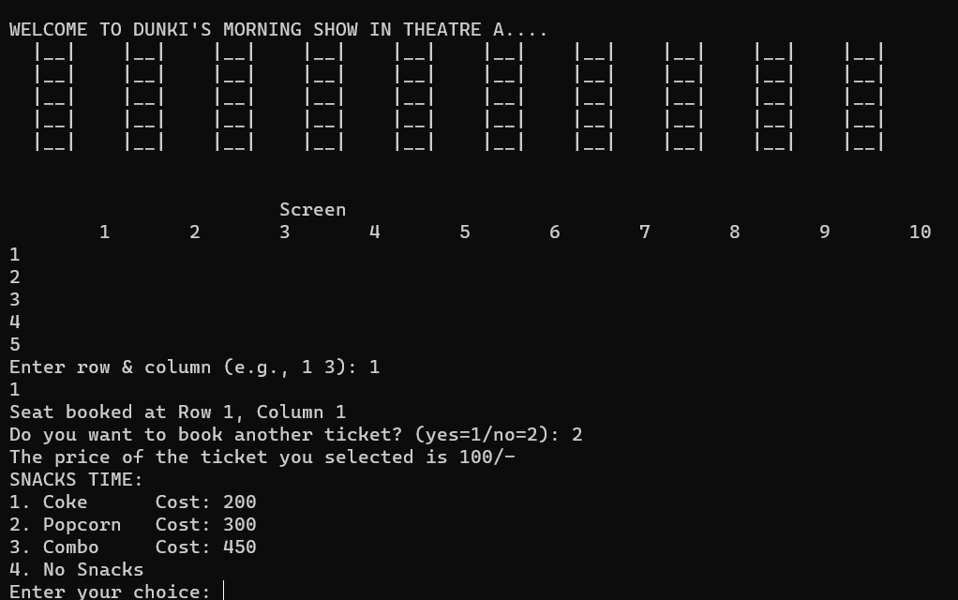After selecting 1 ticket it also allows you to book multiple tickets and after selecting tickets you need then it also prompts for the snacks you can choose if you want or simply choose no snacks
* After entering your choice it display the total cost and asks to enter your mobile number

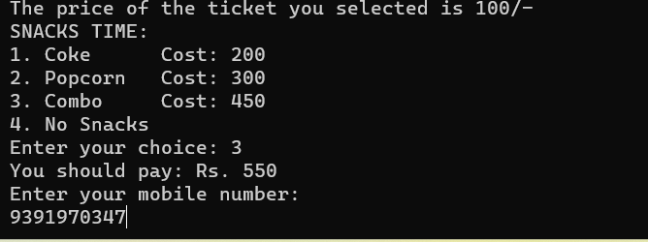

* After entering you mobile number it also allows you to choose among debit card or credit card for the transaction included and then allows you to fill the details of your card displayed down…and then also asks the otp to enter(**make sure to not enter any spaces while providing details of your card)**

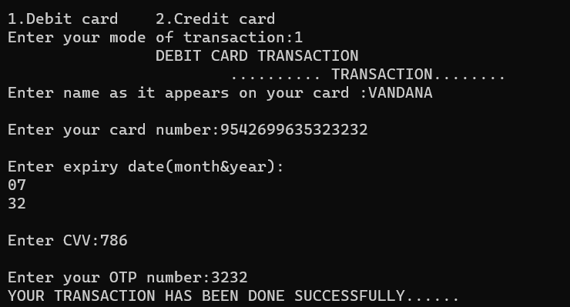

* And then finally it prints the ticket you booked following the process and allows you to return the menu & Program successfully Generated ….

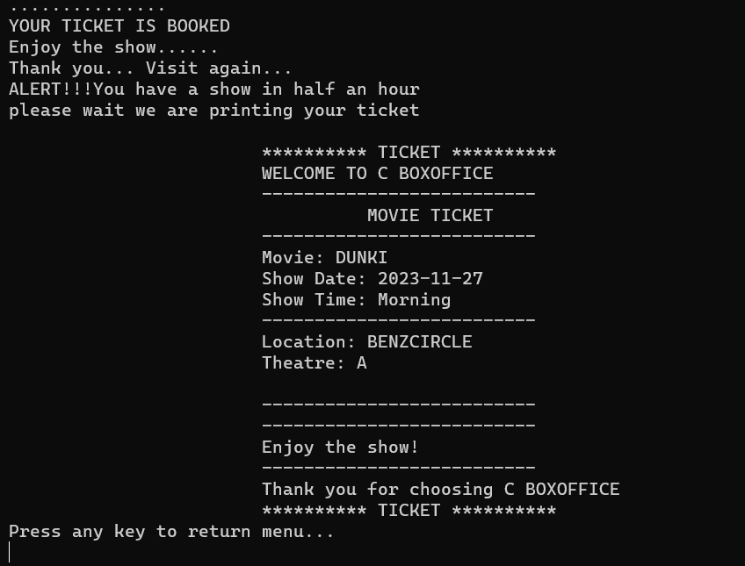

### 5. Future Enhancements

#### **1 User Authentication**

* Implement user authentication to allow registered users to track their bookings.

#### **2 Database Integration**

* Integrate a database to store and retrieve movie and event details.

#### **3 GUI Implementation**

* Develop a graphical user interface (GUI) for a more user-friendly experience.

#### **4 Mobile Application**

* Create a mobile application to extend the service to a broader audience.

### 6. Conclusion

C BoxOffice provides a robust solution for booking movie tickets and event tickets with features for seat selection, transaction handling, and ticket printing. Future enhancements can further improve the user experience and expand the application's capabilities.

This detailed project report outlines the key aspects of the C BoxOffice application, providing a comprehensive overview of its objectives, features, implementation, and potential future developments.

THANK YOU……!!!

THE END